Name: M.Lakshmi Abhista
Roll number: 2420030743
Trello Tool
Step 1: Sign up Trello.com
https://trello.com/
Mail Id: kavithareddy@klh.edu.in
Step 2: Click on Create Workspace, Name itOnline Food Ordering System
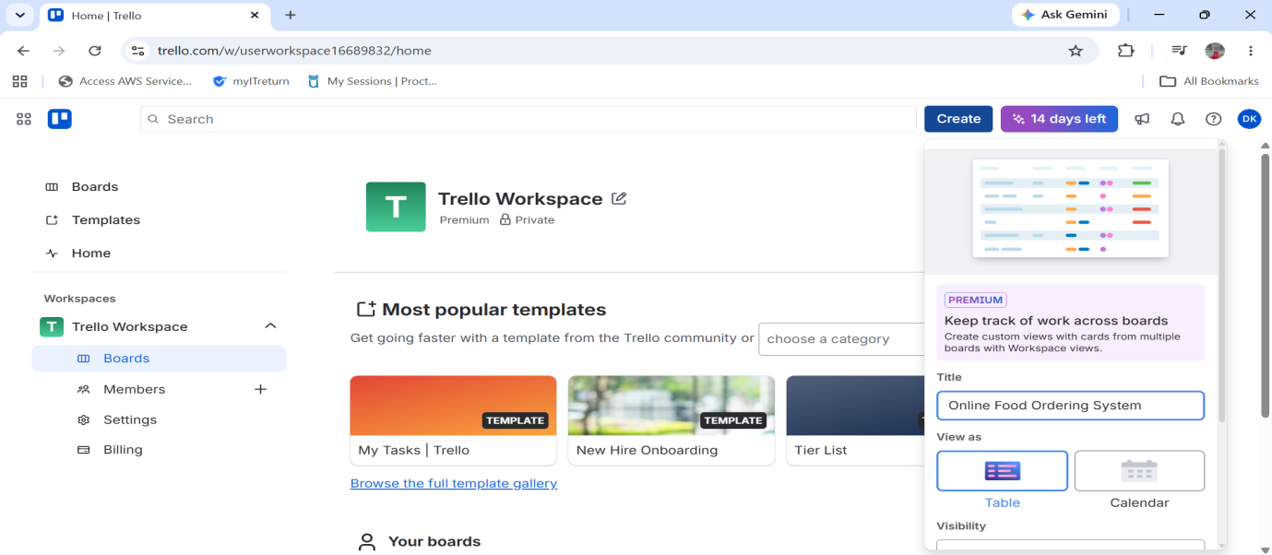
Step 3: Invite team members
Click on Members on left dashboard-->click on Invite Workspace Members and add
For exampleadded(abc and xyz)
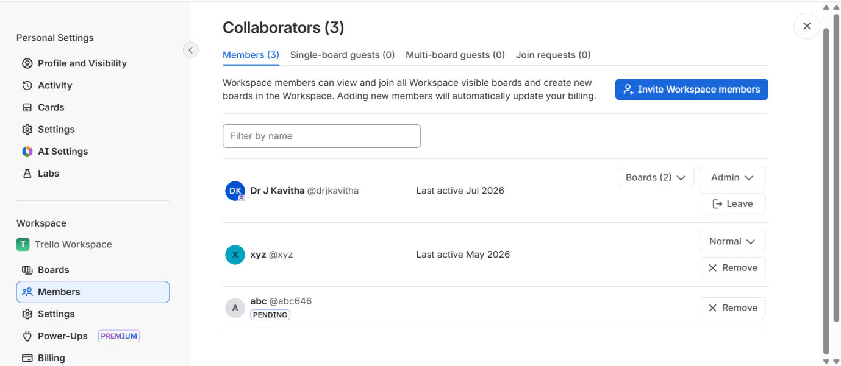

Step 4: Create Project Board-->Board NameFood Ordering App Sprint Board
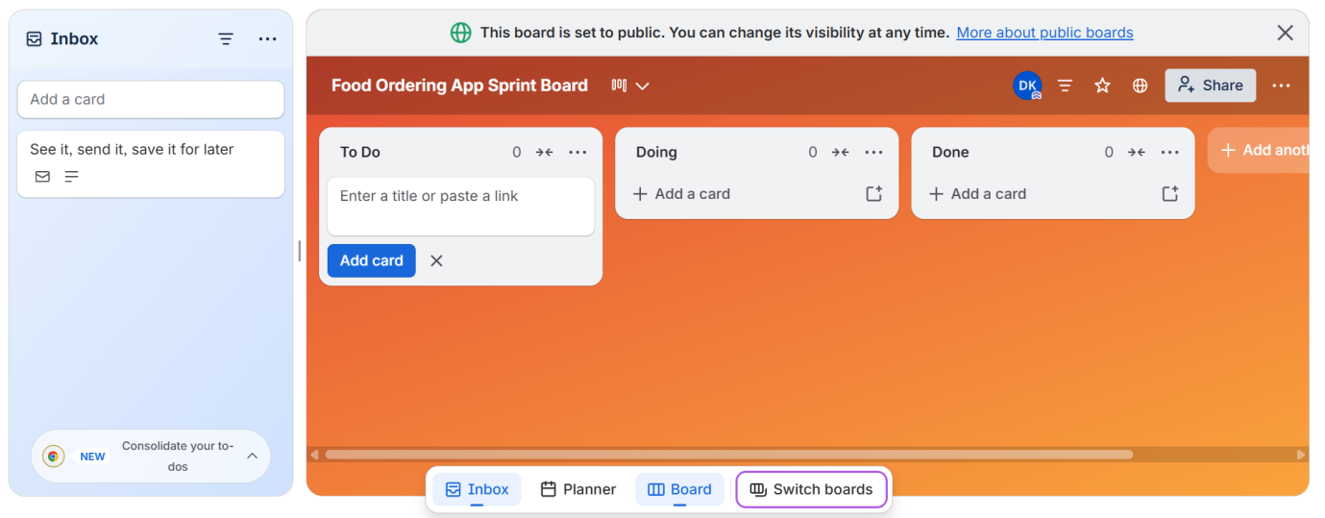
Step 5: Create Lists
Product Backlog
Sprint Backlog
To Do
In Progress
Code Review
Testing
Done

Create all List as follows
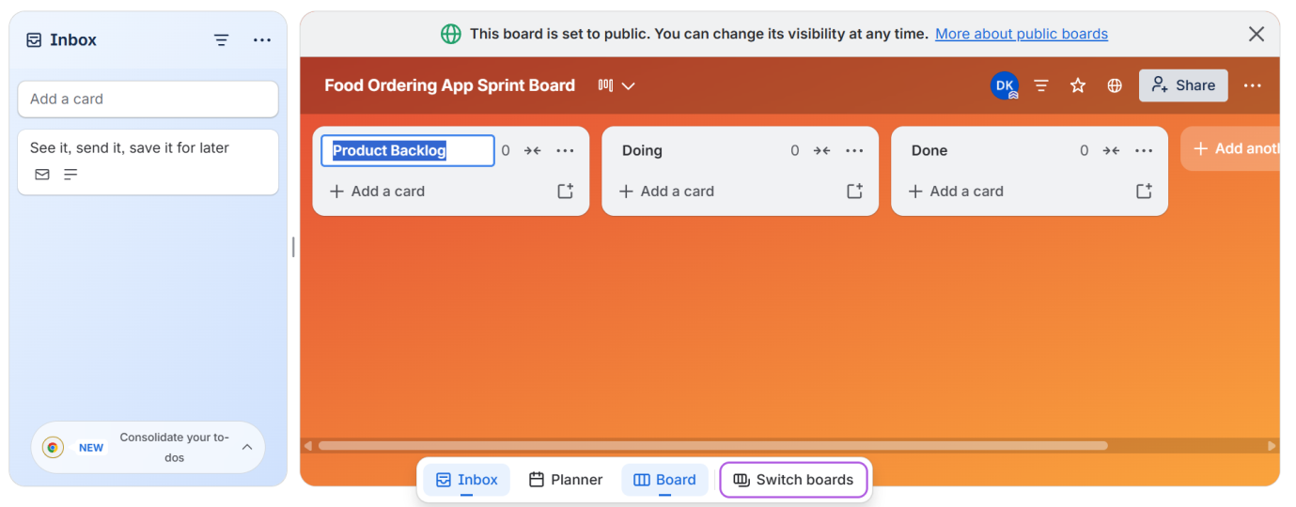

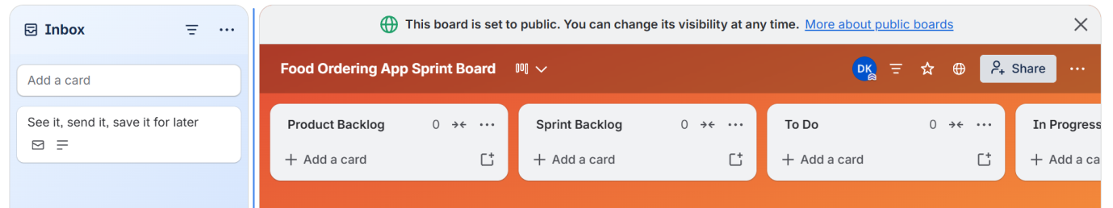

Step 6: Create Card under List

Create cards under Product Backlog.
User Story 1
As a customer,
I want to register an account,
So that I can order food.

User Story 2
As a customer,
I want to login securely,
So that I can access my account.

User Story 3
As a customer,
I want to search restaurants,
So that I can order food quickly.

User Story 4
As a customer,
I want to add food to cart,
So that I can place my order.

User Story 5
As a customer,
I want to pay online,
So that I can complete my purchase.
User Story 6
As a customer,
I want to track my order,
So that I know delivery status.

